In this analysis, the victim host is 192.168.204.162 and the IPs from the attacker are 212.83.135.167, 89.191.150.230 and 188.40.79.151.

Here is the infection traffic in Sguil:

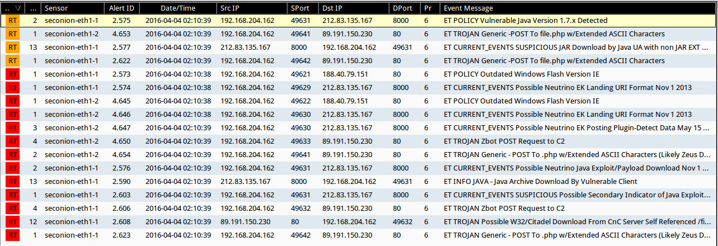

Infection traffic details:

1. **Event:** ET POLICY Vulnerable Java Version 1.7.x Detected

**Content:** Java/1.7.0_ !99

**Explanation:** delivering the Java exploit

**GET /dqjndypi?hlbszwbqmocs=gltiywtx**

**Source IP:** 192.168.204.162 port 49631

**Destination IP:** 212.83.135.167 port 8000

**URL:** eesheshi.ontowess.com

1. **Event:** ET TROJAN Generic -POST To file.php w/Extended ASCII Characters

**Content:** POST /file.php !Referer:

**Explanation:** download a malware file which triggered event

**POST /images/files/file.php**

**Source IP:** 192.168.204.162 port 49641

**Destination IP:** 89.191.150.230 port 80

**URL:** [www.gminalubiewo.pl](http://www.gminalubiewo.pl)

1. **Event:** ET CURRENT_EVENTS SUSPICIOUS JAR Download by Java UA with non JAR EXT matches various EKs

**Content:** !.jar PK .class

**Explanation:** delivering the Java exploit

**GET /dqjndypi?hlbszwbqmocs=gltiywtx**

**Source IP:** 192.168.204.162 port 49631

**Destination IP:** 212.83.135.167 port 8000

**URL:** eesheshi.ontowess.com

1. **Event:** ET POLUCY Outdated Windows Flash Version IE

**Content:** x-flash-version | 3a 20 | !18,0,0,333 | 0d 0a | !21,0,0,197 | 0d 0a | MSIE

**Explanation:** direct to another website

**GET /wp-content/plugins/rotr**

**Source IP:** 192.168.204.162 port 49621

**Destination IP:** 188.40.79.151 port 80

**URL:** 38hartrobertsroad.com

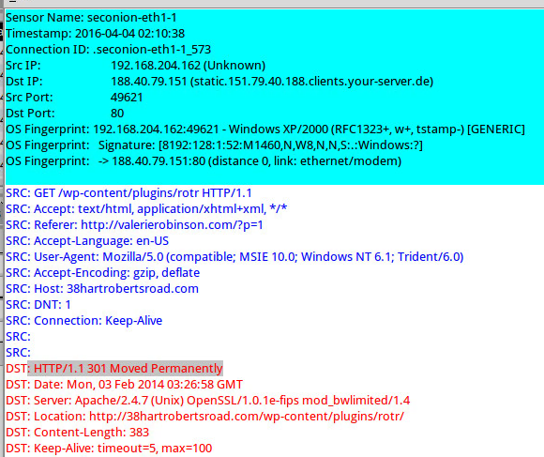

1. **Event:** ET CURRENT_EVENTS Possible Neutrino EK Landing URI Format Nov 1 2013

**Content:** GET ? ; =

**Explanation:** the Java exploit landed on Nov 1 2013.

**GET /fdoufeipqrxkf?zxchqtevykm=2404448**

**GET /ilmcdsiekgu.js**

**Source IP:** 192.168.204.162 port 49629

**Destination IP:** 212.83.135.167 port 8000

**URL:** eesheshi.ontowess.com

1. **Event:** ET CURRENT_EVENTS Possible Neutrino EK Posting Plugin-Detect Data May 15 2013

**Content:** POST XMLHttpRequest

**Explanation:** the Java exploit was post on May 15 2013.

**GET /fjiqivykkrno?zpowtxqkxm=2404448**

**GET /bspxisnw**

**POST /sgphmsawu**

**Source IP:** 192.168.204.162 port 49630

**Destination IP:** 212.83.135.167 port 8000

**URL:** eesheshi.ontowess.com

1. **Event:** ET TROJAN Zbot POST Request to C2

**Content:** POST .php HTTP/1. | 0D 0A | Accept | 3a | !Referer | 3a |

**Explanation:** the download malware file want to control the victim and it should be Zeus.

**POST /images/files/file.php**

**Source IP:** 192.168.204.162 port 49641

**Destination IP:** 89.191.150.230 port 80

**URL:** [www.gminalubiewo.pl](http://www.gminalubiewo.pl)

1. **Event:** ET TROJAN Generic -POST To file.php w/Extended ASCII Characters (Likely Zeus Derivative)

**Content:** POST .php !Referer | 3a | Content-Type | 3a | MSIE

**Explanation:** the download malware file should be Zeus deriavative.

**POST /images/files/file.php**

**Source IP:** 192.168.204.162 port 49641

**Destination IP:** 89.191.150.230 port 80

**URL:** [www.gminalubiewo.pl](http://www.gminalubiewo.pl)

1. **Event:** ET INFO JAVA - Java Archive Download By Vulnerable Client

**Content:** | 0D 0A 0D 0A | PK PK

**Explanation:** delivering the Java exploit

**GET /dqjndypi?hlbszwbqmocs=gltiywtx**

**GET /META-INF/services/javax.xml.datatype.DatatypeFactory**

**GET /kkmohtafl?hnvhxikvyt=gltiywtx**

**Source IP:** 192.168.204.162 port 49630

**Destination IP:** 212.83.135.167 port 8000

**URL:** eesheshi.ontowess.com

1. **Event:** ET CURRENT_EVENTS SUSPICIOUS Possible Secondary Indicator of Java Exploit (Artifact Observed mostly in EKs/a few mis-configured apps)

**Content:** /java.xml.datatype.DatatypeFactory Java/1.

**Explanation:** the message shows it happened the second directory.

**GET /dqjndypi?hlbszwbqmocs=gltiywtx**

**GET /META-INF/services/javax.xml.datatype.DatatypeFactory**

**GET /kkmohtafl?hnvhxikvyt=gltiywtx**

**Source IP:** 192.168.204.162 port 49631

**Destination IP:** 212.83.135.167 port 8000

**URL:** eesheshi.ontowess.com

1. **Event:** ET TROJAN Possible W32/Citadel Download From CnC Server Self Referenced /files/ attachment

**Content:** filename= | 22 | %2e/files/

**Explanation:** it shows the file.php is downloaded.

**POST /images/files/file.php**

**Source IP:** 192.168.204.162 port 49632

**Destination IP:** 89.191.150.230 port 80

**URL:** [www.gminalubiewo.pl](http://www.gminalubiewo.pl)

There are two downloaded files. One is MJ8BBSp4D3uZDSmbE91prhIGA4FmI6bVPLtYhYn5GFiSMda2.zip, a zip file of malware. This file is from 46.161.27.176 port 85 (bewarecommadelimited.org). Its function is to install a FakeAV. The second file is qtcheck.exe, a malicious EXE. It is downloaded from 115.47.49.181 port 80 (no domain name). Its functions is to steal the victim’s password.

As we learned in the class, the “MZ” and “PE” in the content of the packet will cause to fire as a Windows EXE. There are three events, “ET INFO SUSPICIOUS Dotted Quad Host MZ Response”, “ET INFO Executable Retrieved With Minimal HTTP Headers - Potential Second Stage Download”, “ET POLICY PE EXE or DLL Windows file download” contain the content of “MZ” and “PE.” Hence, these three events are the main malicious snort rules/events that fired based on traffic or downloads.

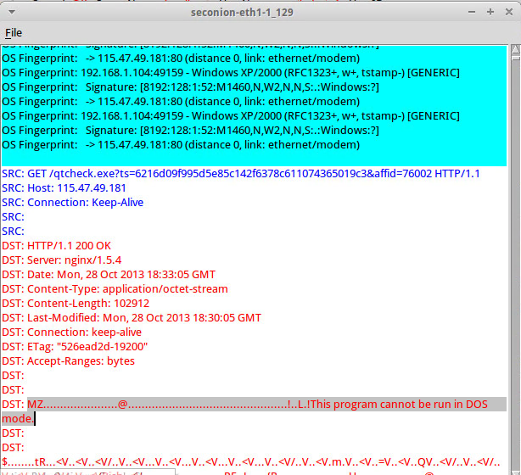

Here is a screenshot from ELSA. It shows all infected events.

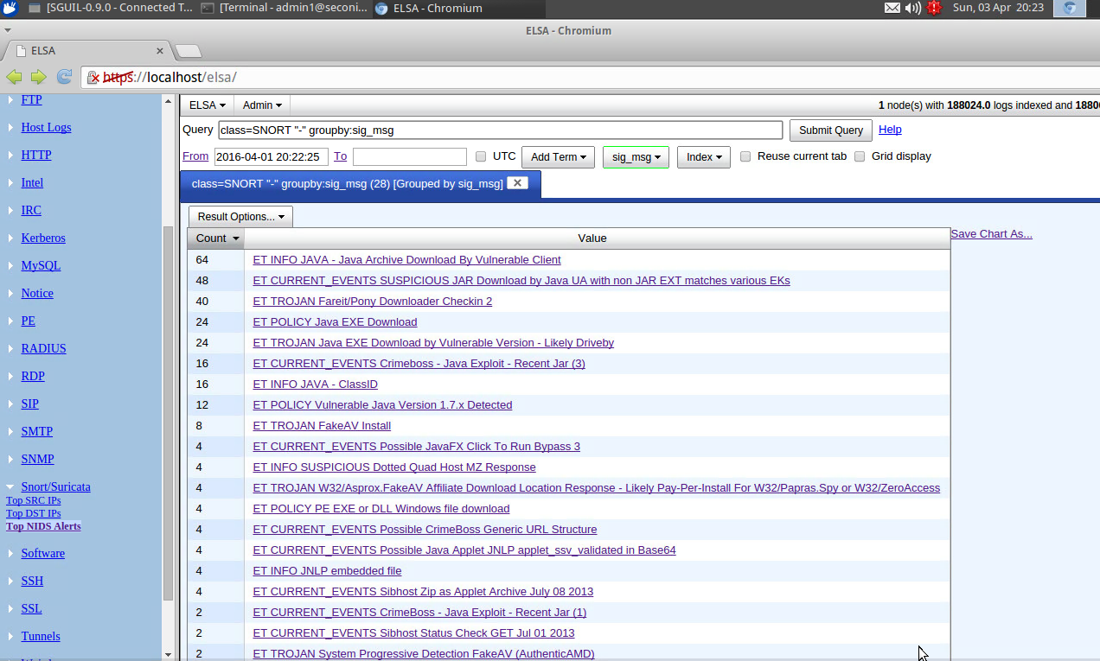

When I click the event of “ET POLICY Java EXE Download” and it shows more details about this event.

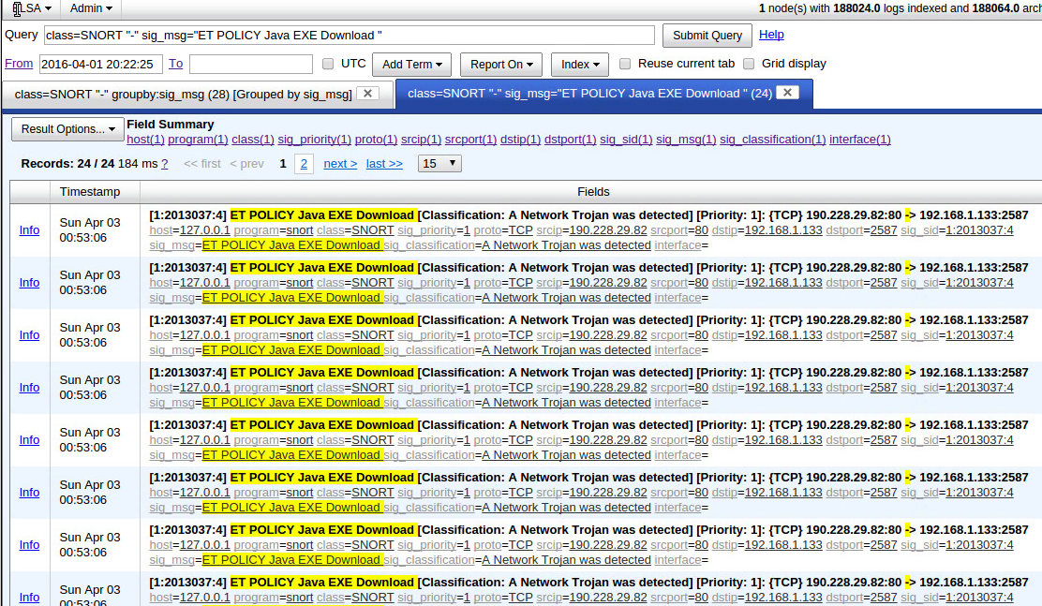

Here is the screenshot form Squert. It shows the geographic distribution which include China, Russia, America, Czech, German, Brazil and Argentina.

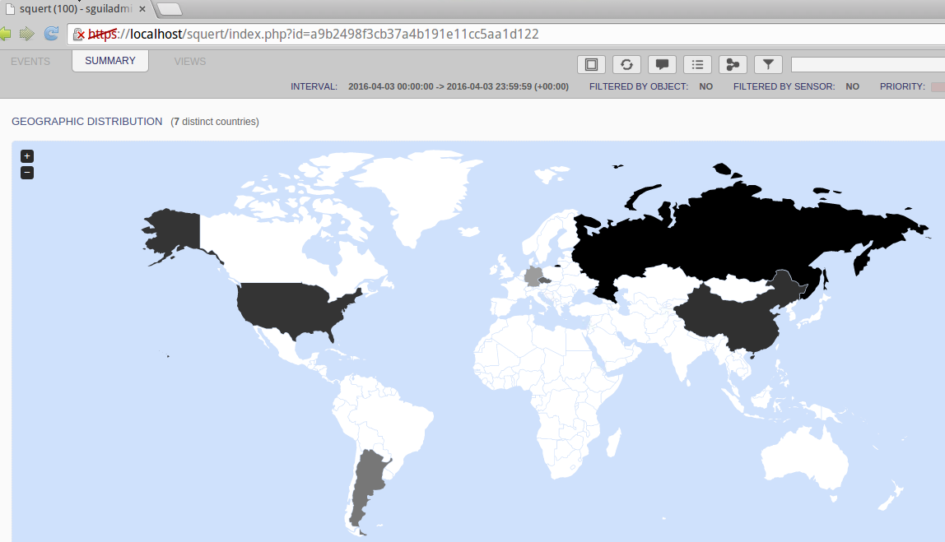

Here is another sceernshot. it shows the top dangerous event is “ET POLICY PE EXE or DLL Windows file download” which fire the exe.

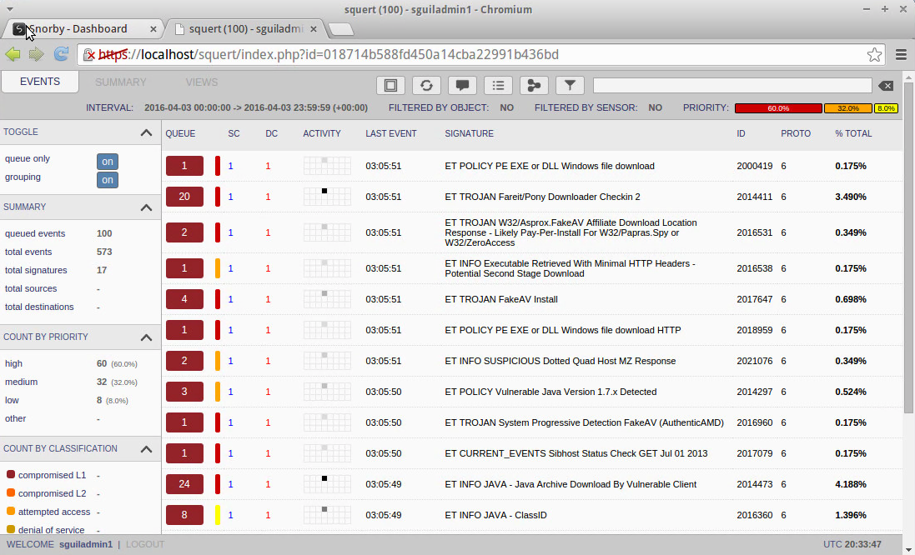

Here is the screenshot from Snorby.

